Author & ‘Danny’ coming to your school – order your copy of this award-winning book!

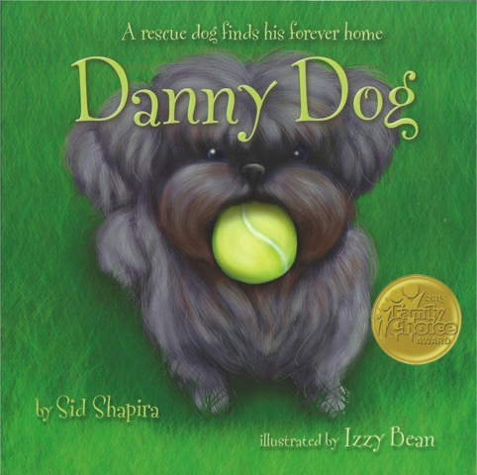

- 2015 Family Choice Award Winner
- RedRover Reader’s “Recommended Books with Humane Themes”
- “Outstanding Community Service” awards from two Calif. State Senators

“Danny Dog is a heartwarming story that is both educational and entertaining… The artwork is wonderful and Danny danced off the page and into my heart! I would love all children to read this wonderful book… It makes you smile. I give it a 10!”

- Carrie Ann Inaba, Judge on “Dancing with the Stars” & Founder, Carrie Ann Inaba Animal Project

----------------------------------------------------------------------------------------------

Order your personalized, author-signed copy to be delivered to your school

Quantity Child’s Name(s) Teacher’s Name

Book: $10.00 each _________________________ _________________

CASH or CHECK (payable to: Sid Shapira Communications)

For more information, please visit: DannyRescueDog.com

ORDER FORMS CAN BE DROPPED OFF IN LIBRARY BY TUESDAY MAY 30, 2017

